**“I-SCROLL”**

**1. PROJECT DESCRIPTION**

You might have seen Hand Gesture Controlled Robots, where the motion of a robot is controlled by the gestures of the hand. Another interesting project based on a similar principle is an Arduino based Hand Gesture Control of your computer or laptop.

Human Machine Interface or HMI is a system comprising of hardware and software that helps in communication and exchange of information between the user (human operator) and the machine. We normally use LED Indicators, Switches, Touch Screens and LCD Displays as a part of HMI devices. Another way to communicate with machines like Robots or Computers is with the help of Hand Gestures.

Instead of using a keyboard, mouse or joystick, we can use our hand gestures to control certain functions of a computer like play/pause a video, move left/right in a photo slideshow, scroll up/down in a web page and many more.

In this project, we have implemented a simple Arduino based hand gesture control where you can control few functions of your web browser like switching between tabs, scrolling up and down in web pages, shift between tasks (applications), play or pause a video and increase or decrease the volume (in VLC Player) with the help of hand gestures.

### Circuit Diagram

The circuit diagram of Arduino part of the project is shown in the following image. It consists of an Arduino UNO board and two Ultrasonic Sensors and you can power up all these components from the laptop’s USB Port.

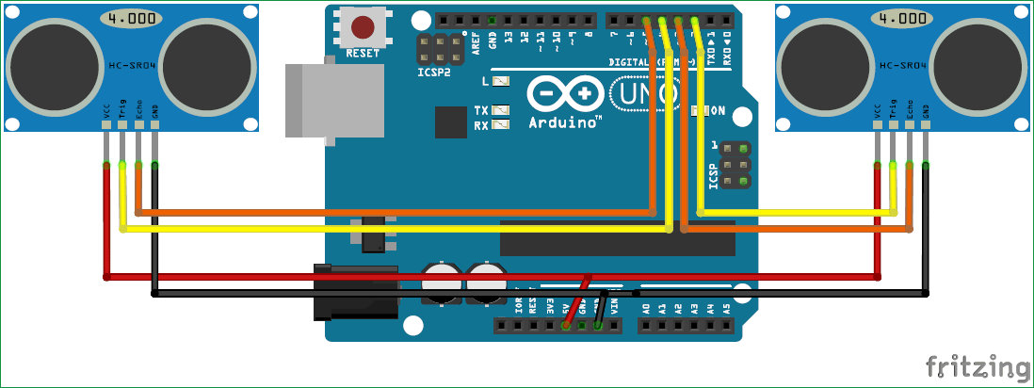

### Working principle of our project

Gesture controlling is based on specifying hand position from the ultrasonic sensor. For processing the raw data, a microcontroller is essential, for that we use Arduino UNO board. Via USB connection the microcontroller transfers the processed and calculated distance value which is provided by the sensor. The data which is send by the sensor is processed in the software in PC where all the calculations are performed and the data is matched with the predefined conditions (gesture resolution). In this model two ultrasonic sensors are used to detect hand position and are connected to the Arduino board. As we know ultrasonic sensor continuously emits sound and it gets reflected back from user’s hand. The distance between the sounds is send and detection of reflect back sound wave is calculated by the micro-controller.

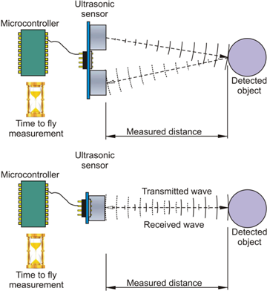

This model has following hardware components, these are two ultrasonic sensor (HCSR-04) and Arduino UNO board. System software includes Arduino IDE and python GUI. To run this model, the python code should run on python GUI first. It matches gestures with predefined conditions and prints on python output shell. Interaction between python and Arduino program happens by writing arduino port number into python program.

### Some screenshots of our project

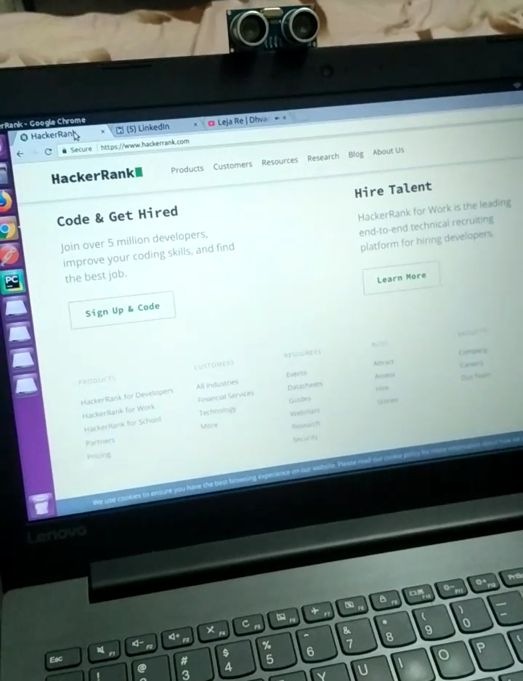

**figure 8(a): screenshot 1 (before the hand flip)**

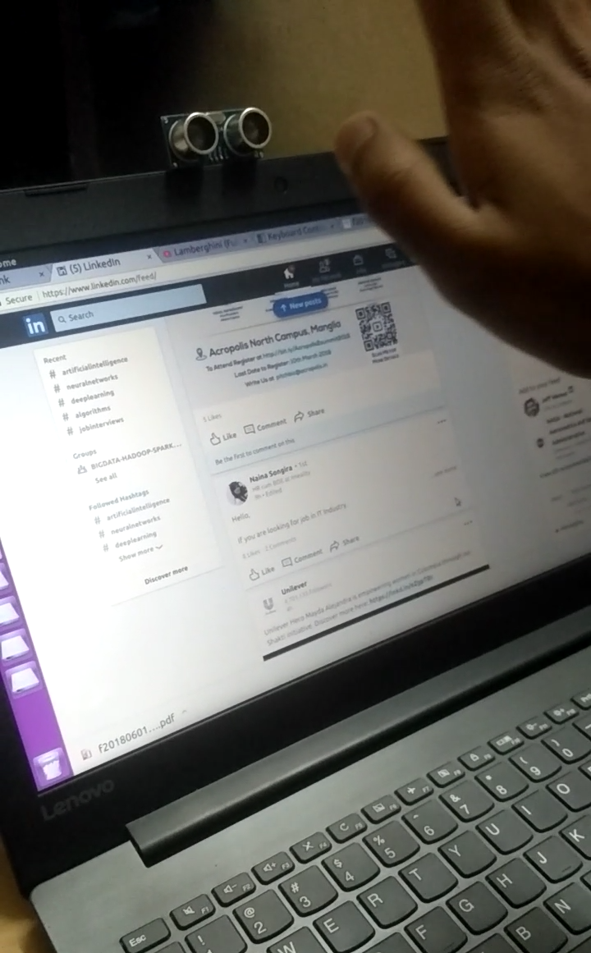

**figure 8(b): screenshot 2 (after the hand flip)**

**Methodology ( Hardware/ Software)**

**Arduino UNO**

The Arduino Uno board is based on the ATmega328. Arduino UNO is an Open-Source Platform and easy to understand for beginners. A vital role in Arduino is played by its standard connecters which lets the CPU board connect to various add-on modules known as shields. Motor controls, GPS, Ethernet, LCD, or breadboard are provided by shield. Arduino IDE (integrated development environment) is used to program Arduino boards in C and C++ programming languages over a serial connection.

**Ultrasonic sensor**

The ultrasonic sensor is used to determine distance to an object. It emits an ultrasound and this sound travels in the air. When it gets to an object it is reflected back to the ultrasonic sensor. The ultrasonic sensor has four pins, these are: VCC, used to powers the sensor, Trigger, to send the US waves, and Echo, the output pin .The US wave is returned back to sensor through eco pin and GND is connected to the ground pin of Arduino board.

### 

### Application of Arduino based Hand Gesture Control of Computer

* In this project, we have implemented Arduino based Hand Gesture Control of Your Computer, where few hand gestures made in front of the computer will perform certain tasks in the computer without using mouse or keyboard.
* Such Gesture based Control of Computers is already present and a company called Leap Motion has been implementing such technology in computers.
* This type of hand gesture control of computers can be used for VR (Virtual Reality), AR (Augmented Reality), 3D Design, Reading Sign Language, etc.
* A number of functions of computer can be operated by using ultrasonic sensor.
* This technique may be very useful for those who does not know functionally of computer. This technique decreases the learning time required.
* Using this technique it is easy to interact with the computer and there is no language barrier.

### Observation

The sensor which is used in this system consumes very less power. The module is developed in low cost. In this system ultrasonic sensor is used to detect hand gesture or distance of hand and according to condition operation is perform on computer. The solution shown in article is implementable and very useful for the user.

### 

### 

### Future scope

Hand gesture technique is not only limited to gaming, using basic function of computer it can be useful for medical applications. Hand gesture technique can work as input method between medical instruments and human body as proposed. It can be used for operating each and every functions of computer.

### Conclusion

This article presents one of the solution among various others, for operating a computer using hand gestures. It is one of the easiest way of interaction between human and computer. It is a cost effective model which is only based on Arduino UNO and ultrasonic sensor. The python IDE allows a seamless integration with Arduino UNO in order to achieve different processing and controlling methods for creating new gesture control solutions.